Basic Troubleshooting - Bruno Elan Stairlift | SRE-3000

Bruno Stairlift Service & Repair 101
In cases where your Bruno Elan SRE-3000 Stairlift is not operating correctly, before calling HME, refer to the solutions listed below. These easy troubleshooting solutions is a fast way to get your stairlift up and running and avoid an unnecessary service call:
• Seat swivel: Is the seat locked in the riding position? If not, the unit will not work (has to be in the locked in position with your feet and body positioned towards wall or railing).
• Barrier arms: Are both arms completely down (rider in seated position) when pressing the rocker switch? Both arms must be down to operate the unit.
• Footrest: Is there an obstruction on the stairway contacting the footrest? If there is, remove the obstruction.
• Carriage safety panels: Is there an obstruction on the stairway that the carriage safety panels are contacting? If there is, remove the obstruction.
• Battery charger: A discharged battery will cause the carriage to move more slowly until the voltage drops to the point where the controller will shut off. If this should occur, pause for a moment, then run the carriage down. Partially charged batteries will run the carriage down, but not up. Confirm that the battery charger is plugged into a live outlet and wait for the batteries to charge.
- Battery charger not charging unit: In the event the battery charger is not charging the unit, do the following:
  - Check to see if the battery charger plugged into a functional outlet? Do not use outlets which are controlled by a wall switch.
  - Is the power light on? Check your panel, the switch may need to be checked.

Charging & Battery Charger LED’s
Keep the batteries charged to ensure optimal operation of your Bruno Elan SRE-3000. The batteries are charging whenever the carriage is parked anywhere on the rail. Failure to keep the batteries charged, or allowing them to fully discharge, will significantly shorten the life of the batteries. Occasionally check the battery charger LED to make sure the stairlift is being charged correctly.
Batteries not cared for properly will need replacement. The warranty on batteries is 3 months.
Charger Diagnostic LED’s
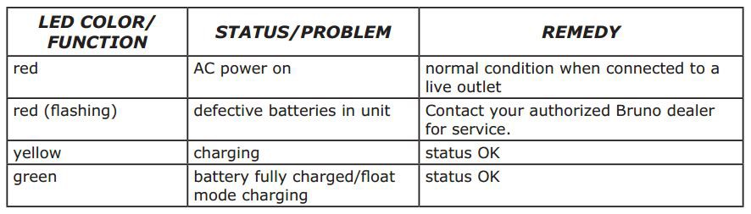

Stairlift Care & Maintenance
Over time the Bruno Elan will run nosier, and squeak. This is a sign that maintenance needs to be performed. This service call can be done by our factory trained technicians, or you may perform the following steps:
For best service life:
• Keep the rail clean and free of debris.
• Keep the battery charger plugged into a live outlet at all times.
• At least once a year, have the stairlift examined, cleaned and lubricated by an authorized Bruno service technician.
Seat Upholstery Cleaning
- All seating and operator contact areas are fabricated of common materials without a history of causing operator reactions or irritations. The SRE-3000 has been designed assuming that the operator will be wearing clothing covering the torso and footwear.
- If the user has special sensitivities, normal clothing precautions are suggested.
- For day-to-day cleaning, use a mild soap and water solution and a soft, lint-free cloth. Do not use vinyl conditioners or protectants. If maintained often a damp towel without soap with do the job, lint-free cloth.

Transmitter Battery Replacement
To replace the battery in the call/send transmitters, remove the access panel on the back of the transmitter.
One 9V battery required. Change batteries annually.

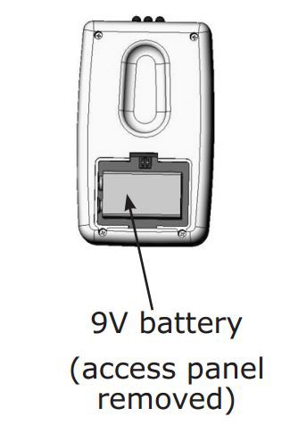

VACATION AND LONG-TERM STORAGE
If the Bruno Elan SRE-3000 will remain unused for an extended period of time, turn off the circuit breaker (ON/OFF switch) on the carriage.
NOTE: The batteries may require recharging before normal use if the stairlift remained unused for an extended period of time.
To recharge, simply turn on the circuit breaker and wait until the battery charger LED indicates that the batteries are fully recharged.

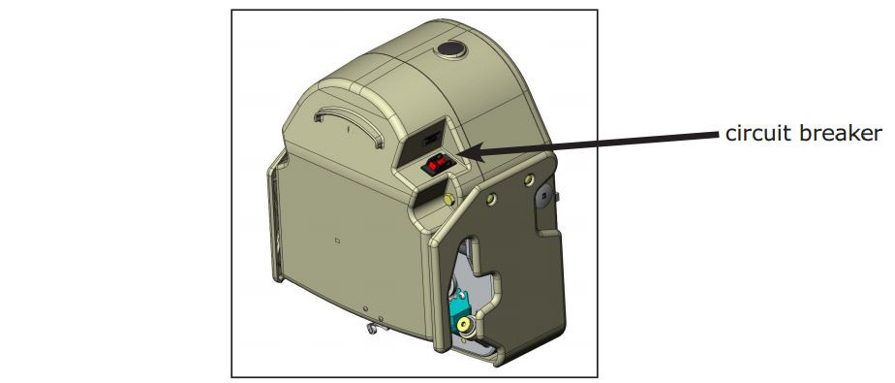
Stairlift Key Operation
Turn the key to its horizontal (ON) position (rotate clockwise)and Vertical (OFF) position (counter-clockwise) to diable the rocker switch on the chair and/or the call/send remotes.
NOTE: Simply turning the key to its vertical (OFF) position does not remove all power from the unit.
To remove all power from the unit, you must turn off the circuit breaker.
